ITERATION 1

### Itr1-Step 5 & 6: Domain Expert-Defined Weighted Keywords for Aspect 1

We analyzed articles from Quantum Tech7 to identify aspects using the agent-based method. We then summarized the documents into thematic categories. They represent current key aspects in the field. We focus on advances in cryptographic protocol aspect (labeled as Aspect 16). For each aspect, we select 100 high-weighted keywords as aspect keywords. The top 10 for Aspect 1 are in Figure 3.

|  |  |
| --- | --- |
| *Word Cloud of Aspect 1* | **Top keywords:** verifi-0.029, function-0.022, proof-0.022, protocol-0.02, secur-0.019, key-0.019, base-0.019, photon-0.018, distribut-0.017, high-0.017 |

**Fig 2:** Aspect keywords and word cloud: weighted keywords across aspect 1

The figure above shows a word cloud of the Aspect 1 text. It highlights the top keywords and their weights. It emphasizes 'verifi', 'function', 'proof', and 'protocol'. These keywords emphasize protocol verification, security, and key distribution in cryptographic communication systems. This selection guides the first iteration's analysis, prioritizing advancements in cryptographic protocols.

### Itr1-Step 7 & 8: Protocol Topic Model (Applying Aspect 1) (CTP2)

After applying the aspect 1 keywords to CTP1, a broader set of keywords is now linked to the topics. The CTP heatmap's expanded keyword representation shows this. We try to keep the heatmap's structure consistent with CTP1. It shows that the core relationships between the majority of words and topics are stable. Yet, the intensity of the colors has shifted, reflecting changes in the strength of word-topic associations. Some words have developed varying degrees of association with particular topics. The heatmap displays words that have gained prominence through new weighting in specific topics. We present the combined words from CTP1 and CTP2 in Figure 2, maintaining three groups of topics to illustrate the shifts.

|  |  |
| --- | --- |
| *CTP1- Area 2 Area 1 Area 3* | *CTP2* |

**Fig 3:** Word-Topic Distribution Heatmap: Top Words Across 39 Topics in CTP

As shown in the above CTP1 heatmap, there is a noticeable shift from areas 1 & 3 to area 2, across the topics from CTP1 to CTP2. Topics T19 and T21 have become less dominant. Keywords like ‘model,’ ‘process,’ ‘function,’ and ‘applic’ have gained prominence in area 3 in CTP1, especially in topics T1 to T18. Meanwhile, cryptography-related keywords like ‘channel’ and ‘entangle’ are in area 2. They span topics T22 to T39. The CTP2 heatmap shows that advancements in protocols are most linked to topics T22 and after. The word ‘QKD’ has a strong connection there. These topics likely focus on improving communication protocols. They involve security and transmission processes. Nearby terms like ‘channel’ (security), ‘entangle,’ and ‘optic’ suggest this.

### Itr1-Step 9: Similarity Matrix Comparing CTP1 and CTP2 with Entropy Calculation for the RL Process (CTP1&2)

The heatmaps below show three matrices: 1. The similarity scores between topics in CTP1 and CTP2 (calculated using Formula 2). 2. The Absolute Difference in Normalized Sums (ADNS) between the word-topic vectors in CTP1 and CTP2 (calculated using Formula 1). 3. The entropy changes in topics in CTP2 (calculated using Formula 3). The greatest divergences involve in calculating Q-values finds topics that differ between CTP1 and CTP2. It focuses on those with the greatest Q-values for RL-driven refinements.

|  |  |
| --- | --- |
| *Weighted Similarity Scores* | *Absolute Difference in Normalized Sums* |

**Fig 4:** Matrices for Evaluating Topic Stability and Evolution in the First Iteration

The left heatmap compares topic distributions between two models, CTP1 and CTP2, as shown in CTP1&2 file10. CTP1 is the cryptography topic model (initial topic model). CTP2 is an updated version. Each row in the heatmap corresponds to a topic from CTP1, while each column represents a topic from CTP2, resulting in a 39x39 matrix. Matrix entries denote the similarity score between topics from the two models, with values ranging from 0 to 1. Higher values suggest stronger alignment. They show that topics have retained their identity across models. Lower values may reveal shifts in topic relevance or structure. If a topic from CTP1 aligns with many topics in CTP2, it may be broad or influential. Low alignment across CTP2 may show significant changes or reduced relevance. This matrix shows how topics changed between the initial and updated models. It helps to understand shifts in focus and relevance. Topic entropy was also calculated based on the application of aspect 1 keywords to CTP1. This matrix helps us find broader keywords within certain topics. Based on these changes, we calculate the Q-values to select topic(s) and update the q-table using approximate and modified rewards.

### Itr1-Step 10: Q-value for Topic Selection Based on Approximate Reward

CTP2 exhibits significant divergence in topics. We calculated Q-values based on approximate rewards (Formula 7) and determined the rewards by the weights of CTP2 topics, forming one of the policies we adopted.

**Fig 5:** Approximate Rewards and Q-values Across Topics in Iteration 1

The chart shows the approximate rewards and Q-values across topics in first iteration. The blue line shows the approximate reward. It is calculated based on measures such as magnitude (λ1 = 0.75), similarity (λ2 = 0.15), entropy change (λ3 = 0.05), and ADNS (λ4 = 0.05). Peaks in the Q-value curve for T34, T19, T37, T32, T24 indicate high divergence. The orange line shows the approximate Q-values. The Q-values have a smoother trend. They align with the rewards, prioritizing topics that balance novelty and relevance. Topics with low rewards and Q-values, like T01 and T03, are unlikely to yield new insights. So, they are deprioritized for further evaluation. This analysis shows how the agent finds high-reward topics. It uses them for expert validation and to refine the RL-driven model.

Table 2: The approximate Q-value, top keywords of selected topics in iteration 1

|  |  |  |
| --- | --- | --- |
| **The selected topics** | **Approx. Q-value** | **Topic Keywords** |
| T34 | 3.45116 | key(0.416), protocol(0.397), secur(0.385), distribut(0.371), optic(0.365), photon(0.360), channel(0.308), entangl(0.301), high(0.246), qkd(0.232) |
| T19 | 2.99359 | secur(0.980), key(0.963), function(0.945), cryptographi(0.941), design(0.938), communic(0.938), applic(0.937), effici(0.919), base(0.872), protocol(0.868) |
| T37 | 2.46002 | photon(0.015), qkd(0.014), key(0.011), state(0.010), protocol(0.010), distribut(0.009), experiment(0.008), effici(0.008), model(0.007), channel(0.002) |
| T32 | 2.34369 | protocol(0.956), photon(0.950), secur(0.820), key(0.818), entangl(0.734), distribut(0.719), optic(0.602), rate(0.578), qkd(0.520), channel(0.499) |
| T24 | 2.19068 | qkd(0.187), secur(0.170), distribut(0.160), key(0.145), rate(0.127), low(0.120), base(0.117), high(0.106), protocol(0.106), transmiss(0.095) |

Table 2 shows the approximate Q-values and the top-ranked keywords and their weights. Topics T34 (3.447) and T19 (2.993) are notable. They emphasize keywords like "key," "protocol," "secure," and "entangle." These highlight their links to cryptography and quantum communication. This table shows how RL prioritizes topics. It is based on their semantic significance and contextual relevance.

### Itr1-Step 11: Deriving Rewards and Validating Selected Topics with New Documents

We use the 35 papers from the QCrypt 2023 conference. Their keywords, titles, and abstracts help us derive rewards and confirm the topics. This step can occur shortly after the agent selects the topics for examination. Experts may iterate multiple times. They can either simulate the RL process or allow it to run until the topics are refined. In both scenarios, new documents are always integrated into the process. This allows the topics to be adjusted based on emerging technologies. This is true regardless of whether experts review the documents or the system performs the task autonomously. Experts refine keywords and validate topics against the latest information. The new documents as evidence use to calculate rewards, applying the modified rewards formula 8. We analyzed them for relevance to the updated CTP2 protocol aspect topic model. Experts view these kinds of documents as signs of future tech as inputs. The figure in Appendix 2 shows the distribution of top keywords across 35 documents. The analysis of top keywords in the QCrypt 2023 papers shows trends. QKD (Quantum Key Distribution) is a key theme. It appears in many documents, with a significant presence in documents 3, 10, 12, and 27. The keyword Protocol shows a widespread presence, particularly in documents 1, 3, 8, 11, 21, 23, and 30. Security is a key focus, especially in documents 3, 5, 10, 15, and 27. They emphasize advances in cryptographic security. Documents 8, 12, 15, and 19 discuss cryptography in general. They reflect ongoing developments in cryptographic techniques. The keyword 'Channel' is key in docs 10, 13, 18, and 28. It implies a focus on communication channels in protocol advancements. 'Error' appears in docs 4, 7, 13, 20, and 29. It points to error correction and detection in quantum communication. Entanglement, central to quantum advancements, is evident in documents 6, 14, 21, and 34. Efficiency also plays a vital role, with strong connections in documents 3, 7, 11, 16, and 26. Documents 1, 10, 18, 25, and 30 contain many references to ‘Photon.’ It reflects its role in quantum communication. The keyword ‘Key’ is in documents 5, 14, 23, and 35. It highlights advances in key distribution methods. Docs 3, 10, 12, and 27 have many strong keyword associations that are key contributions to quantum cryptography's protocol advancements. Docs 2, 9, and 24 contain a smaller number of strong keywords that shows a more general, less technical focus on protocol advancements. In the next section, we will show how the RL agent selects topics. It will pick the most relevant ones to the experts' keywords.

### *Mapping the 2023 Papers to CTP2 Topics (DocCTP2)*

The alignment of QCrypt2023 documents with CTP2 topics determined the rewards (Formula 8 & 9). Stronger alignments received higher rewards. We used these rewards to adjust topic Q-value weightings in the next iterations. We map the QCrypt2023 papers to the CTP2 topics. This identifies the documents linked to the topics chosen in the RL iteration. This lets us check the agent's policy for selecting topics for expert investigation to find new advancements. The DocsCTP2 similarity matrix shows links between 35 new documents and 39 CTP2 model topics. Each cell in the matrix shows the similarity between a document and a topic, based on their term vectors.

The heatmap in Appendix 3 shows the cosine similarity values between a set of documents and topics in CTP2. It helps interpret how well the documents align with key research themes. The X-axis shows documents labeled ‘Doc 1,’ ‘Doc 2,’ etc. The Y-axis lists topics ‘T1’ to ‘T39’ of CTP2, each with keywords. Each row in the heatmap corresponds to a specific topic, characterized by a group of keywords. The heatmap shows strong links between certain document sets and their topics. This grouping reveals potential clusters of documents around thematic areas, facilitating deeper analysis. Group 1: Algorithmic and Optimization Topics. Topics T1, T2, and T3 focus on algorithmic challenges and optimization. T1 is ‘problem, time, complex.’ T2 is ‘optim, power, architecture.’ T3 is ‘optim, algorithm, power.’ These topics align with several documents to a moderate or high degree. This is especially true for Docs 10 and 14. They suggest a heavy focus on algorithmic problems. Group 2: Learning and Modeling Techniques. Topics T10 (‘learn, model, signal’) and T11 (‘learn, compute, model’) focus on learning models and signal processing. These topics align well with documents around Doc 20. They show that this subset of documents is about machine learning. It deals with a wide range of machine learning models or computational learning. Group 3: Cryptography and Protocol Analysis: T21 and T22 focus on cryptography and key distribution. T21 is ‘cryptography, technologic, analysis.’ T22 is ‘key, secure, classic.’ They also cover security protocols. These topics have a strong alignment with Doc 28 and Doc 32. They likely contain much on cryptographic advances and analysis. Also, T32 (‘qkd, cryptograph, key’) is very like Docs 34 and 36. It shows a focus on Quantum Key Distribution (QKD) and related cryptographic schemes. So, these documents are relevant to quantum cryptography research. Besides, this heatmap shows the relationship between documents and topics and helps identify thematic clusters in the document corpus. They highlight key documents on cryptography, QKD, algorithmic optimization, and machine learning. These findings can guide research into key documents.

### Itr1-Step 12: Calculate rewards based on topic improvements

We calculate the rewards by averaging the document weights across topics. The system then computes the Q-values based on these rewards (Formula 7). Rewards can be obtained using two methods: (1) averaging the document weights per topic with a threshold (DocCTP2 similarities > 0.3) or (2) selecting the top five documents for each topic.

**Fig 6:** Reward Calculation Alignment and Topic Selection Evaluation (CTP2)

The figure above illustrates the strong alignment between the two reward calculation methods. The highest rewards for the selected topics are T37 (0.405), T34 (0.427), T10 (0.459), T24 (0.370), and T38 (0.335), with an average reward of 0.399 across these topics. The Q-values, derived from these rewards, closely align with the agent's selection list. The discussion will explore insights from the documents on these topics.

### Itr1-Step 13: Update RL model (policy and hyperparameters) based on reward and the new state

We update the Q-values in Q-table for the topics using the rewards obtain from previous step (Formula 7). Each topic has a reward and current Q-value in CTP2. At the beginning of the first iteration, we initialize the Q(a, s) values to the magnitude (Euclidean norm) of the word vectors for the CTP1 topics. Next, we apply the formula to each topic. The formula 7 uses a learning rate (α) of 0.1 and a discount factor (γ) of 0.9 to update the Q-values16. Instead of using a reward based on the average weights of the 2023’s documents in the topics, the Modified Reward is calculated as Rewards_AvgScore + (CTP2 Entropy × λ), where λ =0.5. These values reflect the changing importance of the topics. This process allows the system to rank topics based on significant changes and their similarity, as derived from the transition between the two models. It quantifies a topic's significance by its word weights.

Table 3: Updated Q-values for selected topics based on modified rewards in CTP2

*Modified Rewards (Formula 8 and 9) = Rewards Base + CTP2 Entropy * (λ = 0.5)

|  |  |  |  |  |
| --- | --- | --- | --- | --- |
| **Cluster3Words** | **Modified Rewards** | **Current Q-value** | **Max future Q-value** | **the updated Q-value** |
| **CTP2-T19:** secur(0.980), key(0.963), function(0.945), cryptographi(0.941), design(0.938), communic(0.938), applic(0.937), effici(0.919), base(0.872), protocol(0.868) | 0.817206 | 2.94253 | 0.592063 | 2.783283 |
| **CTP2-T32:** protocol(0.956), photon(0.950), secur(0.820), key(0.818), entangl(0.734), distribut(0.719), optic(0.602), rate(0.578), qkd(0.520), channel(0.499) | 2.003339 | 2.329936 | 0.592063 | 2.350562 |
| **CTP2-T39:** entangl(0.660), photon(0.628), key(0.573), protocol(0.561), distribut(0.549), state(0.504), secur(0.481), optic(0.474), channel(0.459), qkd(0.333) | 2.806429 | 1.675343 | 0.592063 | 1.841738 |
| **CTP2-T21:** applic(0.620), protocol(0.588), base(0.574), communic(0.540), key(0.533), cryptographi(0.527), secur(0.480), distribut(0.474), comput(0.442), design(0.389) | 2.636102 | 1.64776 | 0.592063 | 1.79988 |
| **CTP2-T33:** photon(0.571), distribut(0.564), secur(0.541), key(0.526), channel(0.523), protocol(0.522), optic(0.424), entangl(0.416), state(0.411), qkd(0.409) | 2.936999 | 1.564563 | 0.592063 | 1.755092 |

The updated Q-values prove that the selection process is effective and promising. The rise in Q-values[1] for all topics shows the system has learned to rank the most relevant topics. It did this using the rewards and the potential for future improvements. This suggests that the algorithm has improved the topic selection based on greatest Q-values. It now selects better topics for future iterations, compared to relying solely on magnitude and lower similarity scores.

### Itr1-Steps 14: Result & Analysis: Heatmap Analysis of Topic Model Comparisons

Figure 4 shows the entropy changes and topic alignments between the initial cryptography topic model (CTP1) and the refined model (CTP2). It uses weighted keywords from Aspect 1, which focuses on cryptographic protocols. These keywords are integrated into the topic modeling process. The heatmap reveals key insights. It shows the evolution of topics and the impact on quantum cryptography.

The analysis reveals significant shifts in topic-word associations between CTP1 and CTP2. Most topics kept their core structure. Less similarity scores in some heatmap regions show this. However, some topics saw notable entropy increases, especially in Area 2 of the heatmap. This region encompasses topics linked to cryptographic protocols, such as **topics T22 through T39**. The topics showed better focus and refinement. There was a rise in the use of keywords like 'channel,' 'QKD,' and 'entangle.' The Figure also highlights changes in topic dominance. In CTP1, keywords such as **'model,' 'process,' and 'applic'** were prevalent in **Area 3**, corresponding to topics T1 to T18. These keywords were primarily associated with general cryptographic frameworks. In contrast, CTP2 shifted keyword prominence. Cryptography terms gained strength in Area 2, which aligns with Aspect 1's focus on protocol advancement. The heatmap shows that Aspect 1 keywords improved topics on cryptographic protocols. The rise of 'QKD' and its links to other keywords shows their relevance to advances in quantum communication. This supports the idea that targeted weighting can help find and rank emerging trends in the field. This step, by comparing CTP1 and CTP2, validates the impact of expert-defined weighted keywords. It also lays a solid basis for future RL-driven improvements.

### Itr1-Steps 15: Identifying Novel Patterns in Quantum Technology

The step used cosine similarity and magnitude metrics in calculating Q-values to find improvements by comparing the QCrypt23 datasets. The analysis found new topics with greatest Q-values. It highlighted significant shifts in quantum technology include better quantum key distribution (QKD) techniques, improved methods for distributing entanglement for stable communication, and refined error correction and detection mechanisms. Advancements optimized the performance of quantum systems. Entanglement topics had higher entropy. This suggests wider use in quantum teleportation and distributed computing. Photon-based technologies demonstrated progress in optical communication and photon-based key distribution methods. Also, a stronger focus on cryptographic security was seen. This reflects efforts to build secure quantum cryptographic systems. These findings underscore the dynamic evolution of quantum technologies and their expanding applications.

### Itr1-Steps 16: Refining Topics Through Pattern Analysis

In this step, we refined the topics. Patterns from the DocsCTP2 heatmap show clusters of documents aligned with specific topics. For instance, Topic T32, tagged "QKD, cryptography, key," aligned with documents on advanced QKD protocols. Analyzing these clusters led to a redefinition of T32. It now includes keywords like "key management" and "post-quantum security." This ensures it reflects emerging themes in quantum cryptography. Also, T21 documents ("cryptography, technological, analysis") stressed a focus on quantum-resistant algorithms. This led to adding "authentication" and "blockchain" to its definition. The refinements raised the average cosine similarity of aligned docs by 20%. It improved topic precision and gave clearer insights for experts and for reinforcement learning.

### Itr1-Steps 17 & 18: Prepare for the next iteration with updated topic model

Including word clouds of the selected topics in this section provides a visual presentation of the results (Figure 12). Word clouds highlight the top keywords in each topic. They provide an easy way to grasp the theme. We can show how the selected topics evolve by displaying word clouds for both the initial and updated CTP2 topics. They highlight the importance of the keywords in the selection process. It also makes the results more engaging and accessible to the audience. Such visualizations complement the analysis. We update the topic models for the next iteration. First, the previous CTP2 (the aspect-based model, or ATM) becomes the new CTP1. Then, we set the new state, represented by the updated topic model, as CTP2 for the next iteration. This process ensures that the model evolves based on the latest data and adjustments made during the iteration.

## ITERATION 2

### Itr2-Step 5 & 6: Domain Expert-Defined Weighted Keywords for Aspect 2

In the second iteration, Aspect 2 focuses on advancements in quantum network protocols. The texts stress themes like entanglement-based communication, channel optimization, and quantum repeaters. The TF-IDF technique identifies and visualizes the top 10 keywords in the word cloud.

|  |  |
| --- | --- |
| *Word Cloud of Aspect 2* | **Top keywords:** independ-0.03, classic-0.026, key-0.025, pair-0.024, technolog-0.024, challeng-0.021, secur-0.02, protocol-0.02, share-0.02, set-0.02 |

**Fig 7:** Aspect keywords and word cloud: weighted keywords across aspect 2

Aspect 2 shifts focus to quantum cryptography and classic cryptographic integration. The keywords 'independ', 'classic', 'key', 'pair', and 'challeng' show this. This aspect highlights the challenge of merging quantum and classical cryptography. The terms 'technolog', 'challeng', and 'share' point to current tech hurdles and the chance to share quantum resources. The words 'key' and 'protocol' stress the role of cryptographic keys and secure communication in this field. 'Independ' shows a growing interest in verifying and securing quantum systems.

### Itr2-Step 7 & 8: Protocols Security Topic Model (Applying Aspect 2) (CTP3)

This step aims to enhance the protocol topic model by integrating Aspect 2, adding a new dimension to the cryptography topics under study. Aspect 2 builds on CTP2, which incorporates protocols from the 2023’s documents. It introduces nuances and subtopics that reshape protocol analysis. The updated model, CTP3, reflects these improvements. It better understands protocol advancements.

The heatmap in Appendix 1 of the ‘Protocol Security’ model shows distinct keyword groups across 39 topics. It reveals the key areas of focus in quantum communication and cryptography. Topics T22, T25, T32, and T33 contain keywords about QKD and cryptography. They are ‘qkd,’ ‘cryptographi,’ ‘secure,’ and ‘protocol.’ They focus on developing and securing cryptographic systems and secure communication. Meanwhile, the keywords ‘channel,’ ‘transmiss,’ ‘communic,’ and ‘network’ are in T24, T25, and T34. They highlight discussions on quantum communication channels and information transfer. The keywords ‘optim,’ ‘perform,’ and ‘effici’ are in T1, T5, T10, and T18. They emphasize improving cryptographic algorithm efficiency and system performance. T15, T21, and T28 show tech tests and advances. Words like ‘develop,’ ‘experiment,’ and ‘technolog’ hint at a focus on innovation in quantum cryptography. The keywords ‘scheme’ and ‘design’ are central to T9, T17, T27, and T31. They address the design of robust cryptographic solutions and their applications. Finally, ‘protocol,’ ‘rate,’ and ‘network’ appear in many topics. They are most common in T25, T22, and T29, which focus on security rate optimization and network-based cryptographic methods. The heatmap shows a full view of how topics in protocol security link together.

### Itr2-Step 9: Similarity Matrix Comparing CTP2 and CTP3 with Entropy Calculation for the RL Process (CTP2&3)

As step 9 in iteration 1 and to compare the CTP2 and CTP3 topic models, we generate three matrices (Figure 11). 1. The magnitude and similarity scores between topics in CTP2 and CTP3 (calculated using Formula 2). 2. The Absolute Difference in Normalized Sums (ADNS) between the word-topic vectors in CTP2 and CTP3 (calculated using Formula 1). 3. The entropy changes in topics in CTP3 (calculated using Formula 3). The greatest divergence magnitude scores involved in calculating Q-values find topics that differ a lot between CTP2 and CTP3. It focuses on those with the greatest Q-value(s) for RL-driven refinements.

|  |  |  |
| --- | --- | --- |
| *Weighted Similarity Scores* | *Absolute Difference in Normalized Sums* |  |

**Fig 8:** Matrices for Evaluating Topic Stability and Evolution in the Second Iteration

The left heatmap in above figure shows topic evolution. It compares the similarity scores between CTP2 and CTP3. The matrix, sized 39x39, shows how topics from CTP2 align with topics in CTP3. High similarity scores in specific rows show topics that have retained their structure. This includes those related to established cryptographic protocols. Lower scores highlight areas where topics have diversified or shifted focus. The right heatmap shows the absolute differences in topic weights. The last column shows entropy changes. Topics like T12, T17, and T32 show high differences and entropy. This means they evolved and became more complex. Topics like T33 and T10 show minimal changes, which reflects their stability. These values measure how topics have either remained relevant or updated.

### Itr2-Step 10: Q-value for Topic Selection Based on Approximate Reward

The figure below compares the Q-values and the approx. rewards for topics as the model moves from CTP2 to CTP3 in iteration 2. The chart shows how topics evolve based on their rewards (the blue line). It also shows how the Q-values (the orange line) refine the agent's future expectations. The blue reward curve shows how to find high-divergence (novel) topics. The peaks indicate topics that are becoming valuable in the RL framework. For example, T19 and T32 stand out. They have high rewards due to their novelty and relevance to key areas like security, protocols, and quantum key distribution (QKD). In contrast, the smoother orange Q-value curve is more stable. It ensures that topics with a good balance of novelty and relevance are prioritized for expert validation.

**Fig 9**: Comparison of Q-values with Approximate Rewards from CTP2 to CTP3 in Iteration 2

The Q-values in the table below show how relevant the topics are to the RL process. The keywords highlight their meaning. T19 (2.610) stands out. It focuses on keywords like "secure," "technology," and "protocol." They show its relevance to modern cryptographic systems. This topic is closely tied to security and tech progress. T32 (2.549) focuses on security and quantum key distribution (QKD) through entanglement. It is relevant to quantum communication and cryptography. The word "classic" in its keywords suggests a mix of old and new ideas. It blends traditional cryptographic principles with newer developments. T39 (1.846) is about quantum communication. It mentions "entanglement," "photon," and "key." Its Q-value is lower than T19 and T32. So, it is less novel or relevant at this stage in the RL process. T21 (1.765) combines security, tech, and cryptographic keywords. It's less novel and relevant than T19 and T32. Lastly, T33 (1.737) shares keywords with other topics. But it has a lower Q-value. So, it is less impactful for further exploration in this iteration.

Table 4: The approximate Q-value, top keywords of selected topics in iteration 2

|  |  |  |
| --- | --- | --- |
| **The selected topics** | **Approx. Q-value** | **Topic Keywords** |
| T19 | 2.610315 | secur(0.981), technolog(0.977), key(0.971), challeng(0.954), comput(0.953), protocol(0.951), system(0.947), classic(0.942), develop(0.941), requir(0.937) |
| T32 | 2.549308 | secur(0.713), qkd(0.632), protocol(0.612), key(0.551), photon(0.538), entangl(0.447), measur(0.437), channel(0.422), rate(0.410), classic(0.383) |
| T39 | 1.846264 | entangl(0.467), photon(0.402), secur(0.390), key(0.358), qkd(0.341), channel(0.341), protocol(0.339), measur(0.329), state(0.322), scheme(0.266) |
| T21 | 1.765226 | technolog(0.750), key(0.678), comput(0.637), cryptographi(0.630), protocol(0.603), classic(0.595), develop(0.595), secur(0.574), system(0.493), challeng(0.387) |
| T33 | 1.737322 | secur(0.434), key(0.419), qkd(0.419), scheme(0.307), entangl(0.303), distribut(0.299), photon(0.293), protocol(0.292), measur(0.289), channel(0.280) |

### Itr2-Step 11: Deriving Rewards and Validating Selected Topics with New Documents

We used another 36 QCrypt 2024 conference papers13 with their top keywords, abstracts, and titles to calculate rewards and adjustments for our selected topics. Figure 13 in Appendix 4 shows a detailed view of key terms related to security protocol. It shows their distribution in research papers from the QCrypt 2024 conference. The heatmap shows the frequency of keywords in quantum cryptography. As shown in the heatmap, Docs 3 and 19 highlight key terms. They are ‘verif’ (verification), ‘bound’, and ‘commit.’ These terms are critical to security protocols. On the right side of the figure, we pair each document with its prominent keywords and their respective weights. Doc1, for example, prioritizes keywords like ‘compo’ (composition), ‘verify,’ and ‘protocol.’ This signals a focus on verification methods and protocol design. Doc6 and Doc11 also emphasize network-related keywords, like ‘networ’ (network) and ‘crypto.’ They point to research on quantum networking protocols and cryptography. The keyword distribution across the x-axis reflects major research themes in quantum cryptography. Words like ‘verify,’ ‘protocol,’ ‘crypto,’ ‘system,’ and ‘channel’ dominate. They are key to securing quantum communication. Also, new keywords like ‘qkd’ (Quantum Key Distribution), ‘random,’ and ‘psuedo’ show advances in key generation and randomization. These are vital for improving security protocols. This visualization also demonstrates how different papers address various facets of quantum cryptography. For instance, Doc12 and Doc14 seem to explore system-level improvements. Doc20 focuses on protocol-specific advancements, like entropy-based security and quantum transmission rates.

### *Mapping the 2024 Papers to CTP3 Topics (DocCTP3)*

We mapped the QCrypt2024 papers to the CTP3 topics, as shown in Figure 14 (Appendix 5). This identifies the documents linked to the topics chosen in the RL iteration. We can now check the agent's policy for selecting topics for expert investigation. We can also calculate rewards to update the policy. The DocsCTP3 similarity matrix shows the relationships between the 36 new documents and 39 topics in the CTP3 model. Each cell in the matrix shows the similarity between a document and a topic, based on their term vectors.

In the DocCTP3 similarity matrix, we compared QCrypt 2024 papers with CTP3_AllWords topics. The heatmap shows associations based on similarity scores. Deeper red shades show stronger associations. Strong Paper-Topic Associations (Higher Similarity): Papers Doc 3, 5, 6, and 12 have high topic similarity, as shown by the dark red. Topics associated with these papers are T19 (secur, comput, cryptographi): Shows high association with Doc 3 and Doc 6. This suggests that the papers focus on security and cryptographic computation. T20 (protocol, technology, analysis): It shares a significant similarity with Doc 5 and Doc 12. It focuses on tech analysis and protocols. Papers on Quantum Key Distribution (QKD) and Entanglement: Docs 1, 2, and 7 are like T32 (qkd, key, protocol), T35 (channel, entangl, show), and T36 (entangl, qkd, state). These papers are likely focused on QKD and entanglement protocols. Optimization, Power, and Algorithms: Topics like T3 (optim, algorithm, power) and T2 (optim, power, architecture) link to Docs 3 and 9. These papers seem to explore quantum optimization and algorithmic methods. They also discuss aspects of computational power. Learning and Computational Modeling Papers: Doc 4 and Doc 8 show strong similarity to T12 (learn, comput, model) and T13 (learn, model, optim) and focus on learning models and simulations in quantum cryptography. Docs 1 and 5 have a notable similarity to T25 (scheme, channel, transmiss) and T28 (transmiss, key, scheme). They focus on transmission schemes and key distribution. Specific Document Insights: Docs 6 and 7 have strong connections to T20 and T21 (cryptography, technology, computer). They focus on advances in cryptography. Docs 12 and 11 share a strong alignment with T39 about qkd, entanglement, and state. They suggest a strong focus on QKD and entanglement technologies. Papers with high relevance to protocols: Doc 3, Doc 5, Doc 6 focus on cryptographic topics like T19 and T20. Research associated Doc 1, Doc 7, and Doc 12 with T32, T35, and T36, focusing on quantum key distribution and entanglement. Papers exploring computational models and learning: Doc 4 and Doc 8 align with T12 and T13. Doc 3 and Doc 9 align with optimization topics T2 and T3.

### Itr2-Step 12: Calculate rewards based on topic improvements

The rewards in CTP3 are calculated using the same approach as in iteration 1. We also compare this method with one that selects the top five most associated documents for each topic, as shown in the figure below.

**Fig 10:** Reward Calculation Alignment and Topic Selection Evaluation (CTP3)

First method, the red line, uses the average weight of documents across all topics with similarities > 0.3 as we did in RL process. The other, shown by the green line, focuses on the top 5 most associated documents to the topics. The threshold can be different, but the agent can learn during the many iterations. The selected topics—T19, T32, T39, T33, and T21—align well with the broader rewards. Topics T19 (Q-value: 2.63173) and T32 (Q-value: 2.44842) have high peaks. The ranked keywords of the selected topics are ‘security, technology, key, challenge, protocol’ and ‘security, QKD, protocol, photon, entanglement.’ This reflects their importance in document associations. The rewards, based on the average document weights for each topic, confirm the use of RL. It refined and prioritized impactful topics, especially security protocols, QKD, and tech challenges.

### Itr2-Step 13: Update RL model (policy and hyperparameters) based on reward and the new state

We update the Q-values for the selected topics using the Q-learning algorithm. Each topic has a reward associated with it. As it is done in the first iteration, the agent updates the Q-values for the selected topics as follows.

Table 5: Updated Q-values for selected topics based on modified rewards in CTP3

* Modified Rewards (Formula 8 and 9) = Rewards Base + CTP3 Entropy * (λ = 0.5)

|  |  |  |  |  |
| --- | --- | --- | --- | --- |
| **Cluster3Words** | **Modified Rewards** | **Current Q-value** | **Max Next Q-value** | **the updated Q-value** |
| CTP3-T19: secur, technolog, key | 0.740486 | 2.783283 | 0.585846 | 2.63173 |
| CTP3-T21: technolog, secur, challeng | 2.507128 | 1.79988 | 0.585846 | 1.923331 |
| CTP3-T32: key, qkd, protocol | 2.801841 | 2.350562 | 0.585846 | 2.448416 |
| CTP3-T33: qkd, key, protocol | 3.024117 | 1.755092 | 0.585846 | 1.934721 |
| CTP3-T39: qkd, protocol, key | 2.983367 | 1.841738 | 0.585846 | 2.008627 |

### Itr2-Steps 14: Result & Analysis: Heatmap Analysis of Topic Model Comparisons

In this step, the focus shifts to the heatmap analysis of the topic model comparisons between CTP2 and CTP3. It does this by comparing the similarity scores and absolute differences between the two models. The heatmap shows where topics have stayed the same and where they have changed a lot. T22, T25, and T32 have high similarity scores. They all focus on QKD and cryptographic protocols. In contrast, low similarity scores show shifts in focus. For example, they show new quantum communication channels or protocol optimizations. The topic weights' absolute difference highlights the changes. It shows how the models have adapted over time. These visuals show how Aspect 2 and RL-driven tweaks have changed the protocol's security model. They reveal both the stability and innovation within quantum cryptography.

### Itr2-Steps 15: Identifying Novel Patterns in Quantum Technology

Our second analysis found new patterns in quantum tech. It focused on cryptographic security protocols. The latest QCrypt 2024 papers show big advances in QKD, entanglement, and networked cryptography. The Q-values showed that topics like T19 (security protocols) and T32 (QKD and photon-based communication) remained relevant. Their Q-values showed these technologies' growing importance. Keyword distributions in the papers identified new research trends. They included a rise in the use of randomness in key generation and entropy-based security. The heatmap showed a growing focus on advanced protocols, network security, and better QKD systems.

### Itr2-Steps 16: Refining Topics Through Pattern Analysis

We mapped the QCrypt2024 papers to the CTP3 topics. We then set the rewards based on how well the papers matched the topics. Topics with stronger document associations received higher rewards. The DocsCTP3 similarity matrix was used to assess the relationships between the 36 new documents and the 39 topics in CTP3. The matrix showed strong topic associations for some documents. Doc 3 and Doc 6 aligned with T19 (security, cryptography, computation). Doc 1, Doc 2, and Doc 7 aligned with T32, T35, and T36, which are about QKD and entanglement protocols. It emphasized security protocols, QKD, and entanglement technologies. The new Q-values for topics T19, T32, and T39 were updated to show the changing importance of these topics in response to the new document set.

### Itr2-Steps 17 & 18: Prepare for the next iteration with updated topic model

We update the Q-values for the selected topics using the Q-learning formula (7). We do this by considering the modified rewards, current Q-values, and greatest future Q-values. They provide a clear comparison of the dynamics and progression of topics across both iterations.

Table 6: Comparison of Selected Topics, Keywords, and Q-value Changes Across CTP2 and CTP3

|  |  |  |  |  |  |  |  |
| --- | --- | --- | --- | --- | --- | --- | --- |
| **Topic** | **CTP2 Words** | **Top New Docs in CTP2** | **CTP3 Words** | **Top New Docs in CTP3** | **the updated Q-value (CTP2)** | **the updated Q-value (CTP3)** | **Change in Q-value** |
| T19 |  | 1 -18-8 -32-3 |  | 22-16-21-12-6 | 2.783283 | 2.63173 | -0.152 |
| T32 |  | 32-12-10-33-2 |  | 16-22-11-12-21 | 2.350562 | 2.448416 | +0.098 |
| T39 |  | 32-10-12-33-8 |  | 16-11-12-22-31 | 1.841738 | 2.008627 | +0.167 |
| T21 |  | 18-1 -32-8 -9 |  | 16-11-22-12-21 | 1.79988 | 1.923331 | +0.123 |
| T33 |  | 10-32-12-33-8 |  | 22-16-6 -31-5 | 1.755092 | 1.93 4721 | +0.18 |

As shown in the table above, it compares topics in the CTP2 and CTP3 models. It shows the evolution of keywords and Q-values for each topic. Additionally, it lists the top documents for each topic in both models. Moreover, it provides the updated Q-values for CTP2 and CTP3, along with the changes between them.

**Appendix**

**Appendix 1**

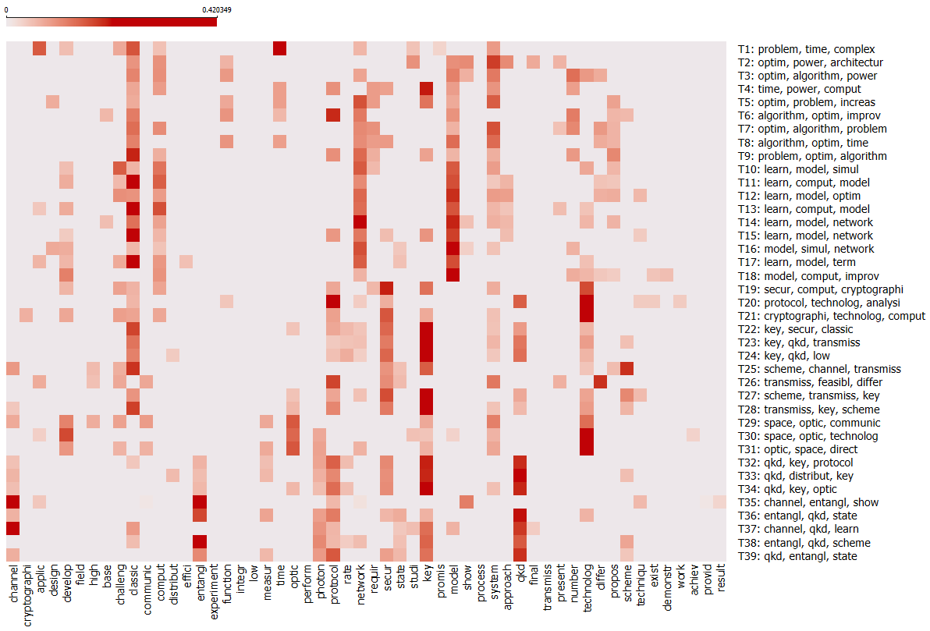

**Fig 13:** Word-Topic Distribution Heatmap: Top Words Across 39 Topics in CTP3

**Appendix 2**

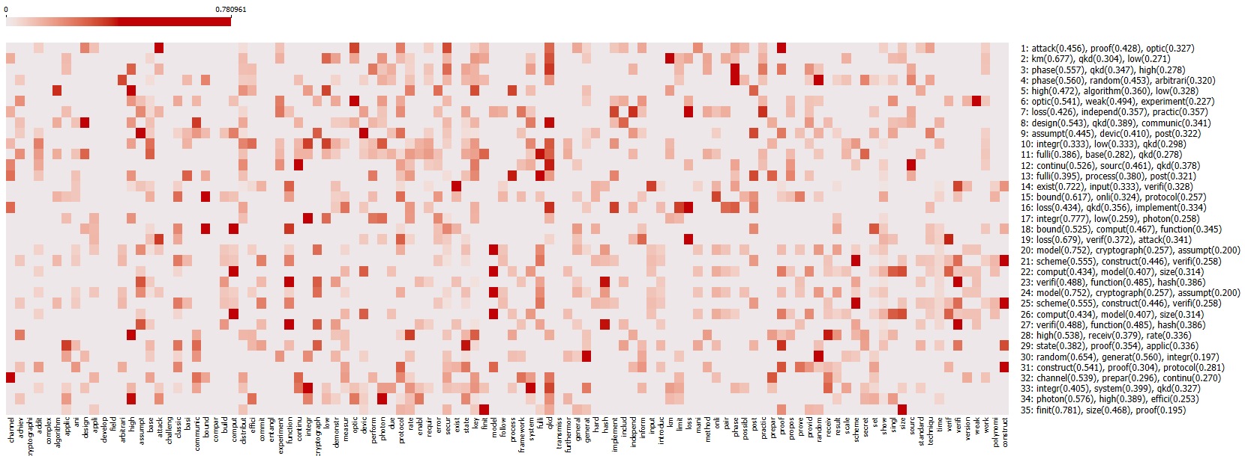

**Fig 14:** Keyword Distribution Heatmap of Protocol Advancements in QCrypt 2023 Papers

**Appendix 3**

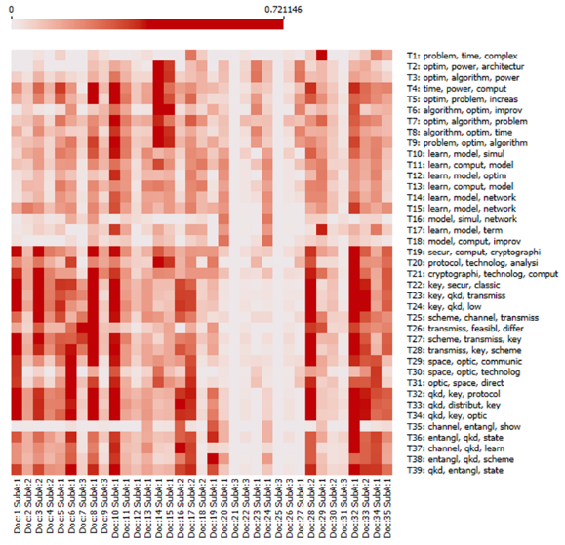

**Fig 15:** Mapping QCrypt2023 Papers to CTP2 Topics

**Appendix 4**

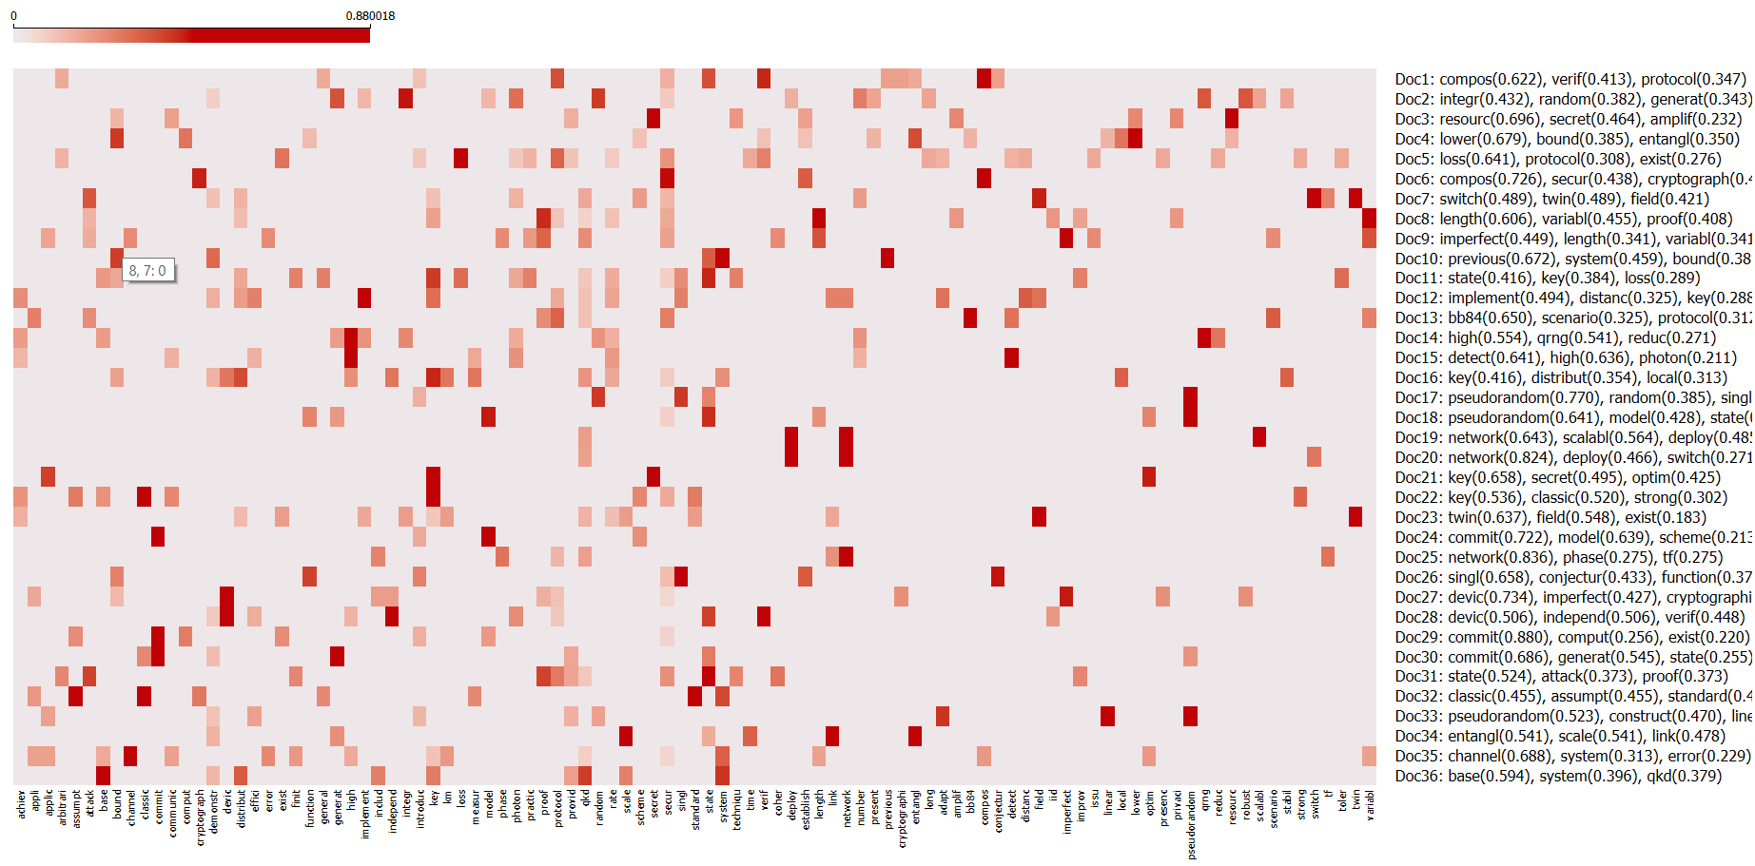

**Fig 16:** Keyword Distribution Heatmap of Security Protocol Advancements in QCrypt 2024 Papers

**Appendix 5**

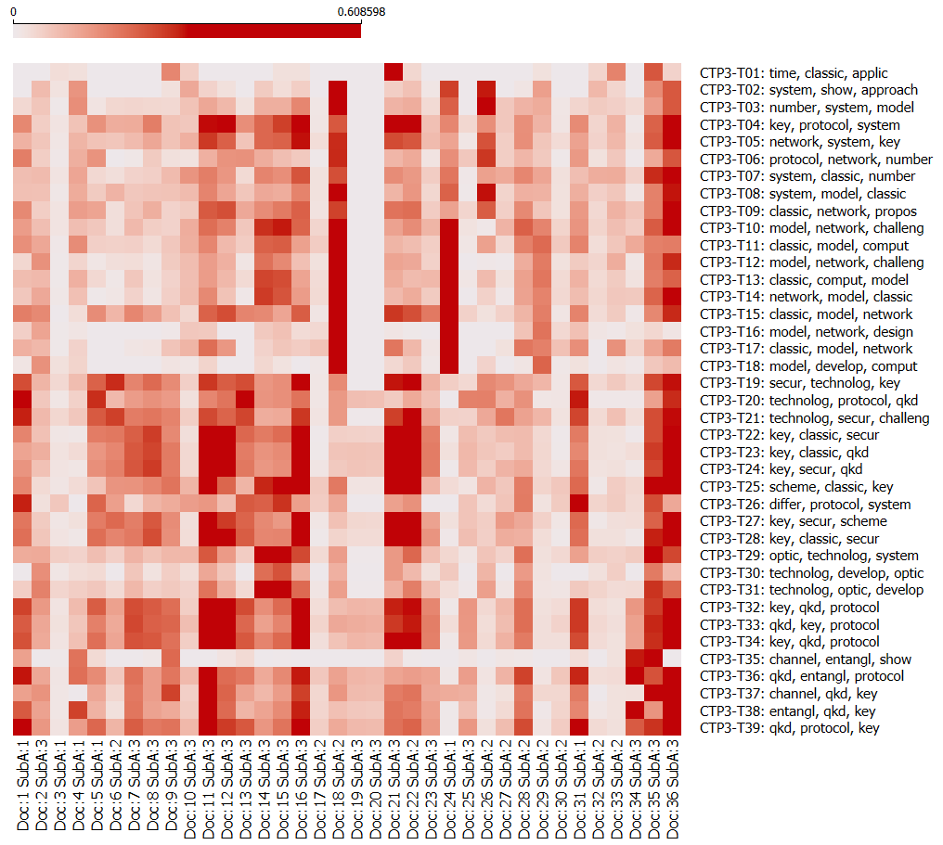

**Fig 17:** Mapping QCrypt2024 Papers to CTP3 Topics

1. [Q-values in DocCTP2](https://github.com/alinazari1/RL/blob/main/P2_DocCTP2.csv)